Assignment 15

Task 1. Create a map showing the usage of stations for the region and passenger numbers chosen in the slicers, Add a tooltip field so that you can see which station you're looking at:

Step 1. Select Map from Visualisation and add the field as shown in image below

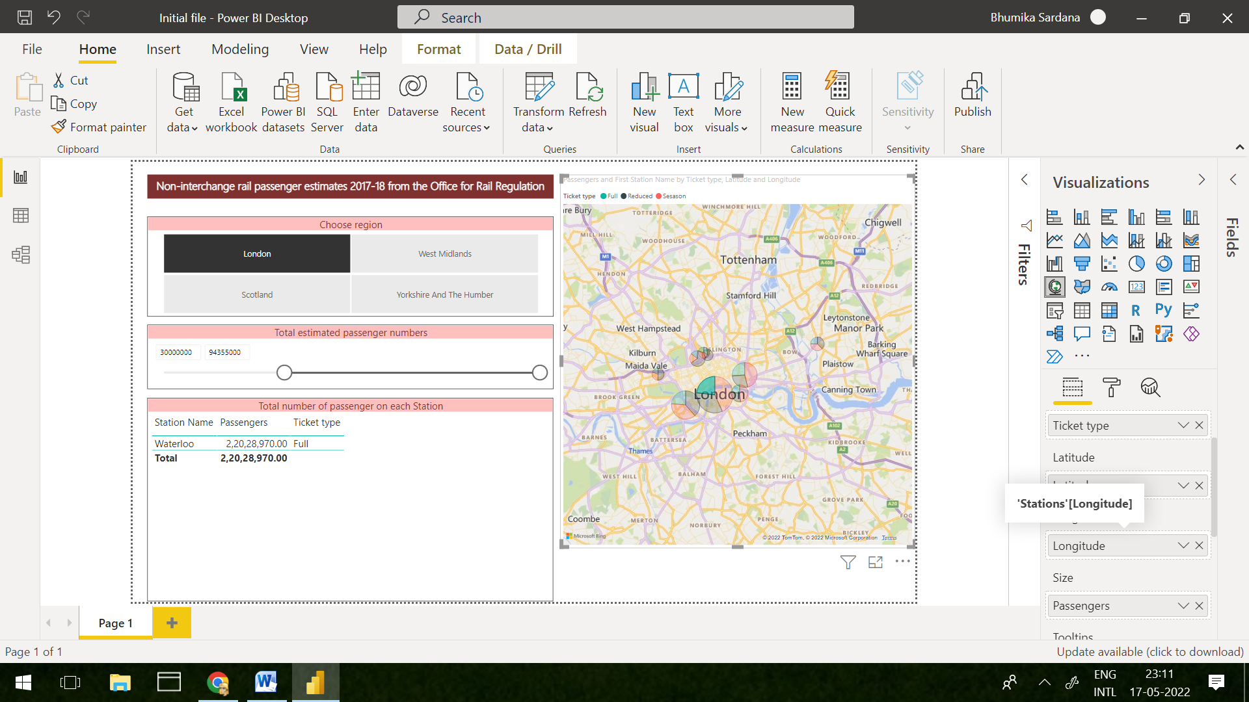

Step 2. To create tooltip add Station Name in Tooltips section.

Step 3. Choose table from Visualisation and upon adding fields as shown in image.Click on station in map for the desired output.

